My Right Career Web Application Architecture v 1.0

# High Level System Architecture

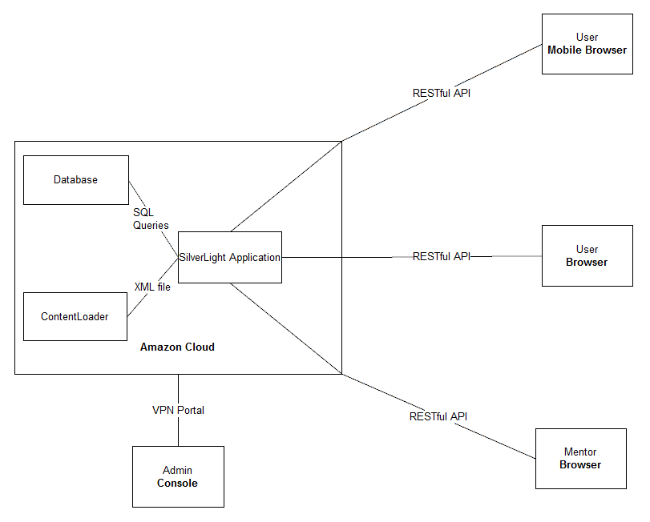

This is a representation of how the application works over the various pieces of hardware and software. The application itself will be hosted on Amazon Cloud along with an external Content Loader that manages the content of the websites through local files and folder, and a SQL database. All of this is stored on a server. Any Admins can access this through a VPN client and Users will use their local browser.

# Server System Stack

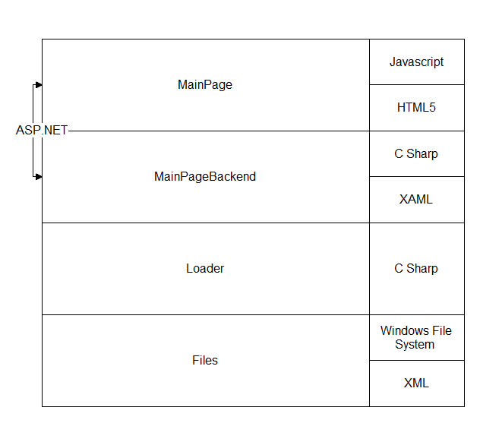

This is the high level stack for the project. The files that build the webpage are stored on the local Windows file system in XML. The Loader that read in those files is underneath that and passes the parsed documents to the SilverLight application that takes those files and generates the HTML and Javascript that is actually sent to Users.

# Architecture Diagram

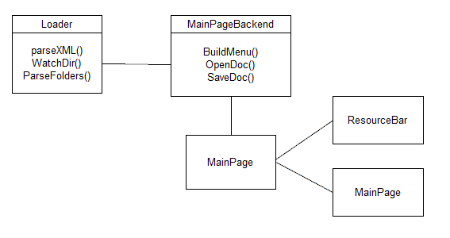

Currently this is the architecture of the prototype application that we are developing. This the basic setup, but will be expanded as we develop more of the functionality of the application.

# Class Diagram

This will be developed once the prototype is finished and the team can use the knowledge gained from development so far to generate an accurate Class Diagram.